3. Step: Article Creation SOP

10 Simple Steps - Overview
- Create a Catchy Title Including the Keyword
- Create Introduction and Meta Description
- Create FAQ Section
- Insert Target Keyword in 1st H2 (right underneath the Introduction)
- Insert Pictures and Descriptions
- Set Featured Image
- Reread Content
- Set Url (usually I use "domain.com/keyword")
- Choose and Set the Category
- Publish

Detailed SOP to Create Optimized & Engaging Articles in <15 Minutes

1. Create a Catchy Title Including the Keyword
- Use our catchy title generator to create an engaging yet relevant title.
- Incorporate numbers and power words (e.g., “[X] Best… You Need to See”) to spark curiosity.

2. Create an Introduction and Meta Description
- Check out our prompt at the end here to generate a great intro and meta description.
Feel free to tweak it to match your tone and style.

3. Create FAQ Section
- Our prompt already includes optimized FAQs, but you can also check Google’s "People Also Ask" section to find additional highly relevant questions.
- The more aligned these are with your KW and your topic, the better for your site.
This is also a good place to include other relevant secondary KWs.
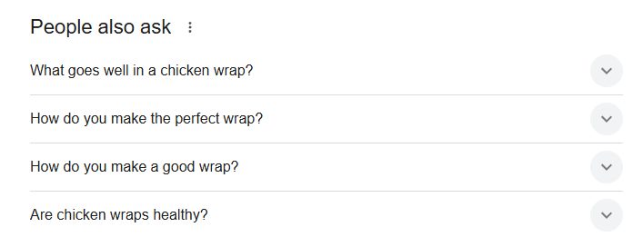

4. Use Your Target Keyword in the First H2 (Right Below the Intro)
After the introduction, make sure the first H2 includes your main KW.

Here is an example:
- Keyword: Work Outfit
- Title: 30+ Work Outfit Ideas Your Colleagues Will Adore
- First H2: Work Outfit Ideas Your Colleagues Will Love

5. Add Images & Descriptions
This is especially important for listicles (remember: this is the best-performing blog post type for Pinterest).
- Where to Find Images?
  - Pinterest or Instagram (ask creators for permission & credit them)
  - AI tools (Midjourney, Ideogram)
  - ContentGoblin, GetPinMaker (you can find more information about our workflow with these tools here)
- Image Formatting:
Each image should have:
  - A title
  - A short description (e.g., why the style works, when to wear it, how to recreate it)
  - An optimized alt text
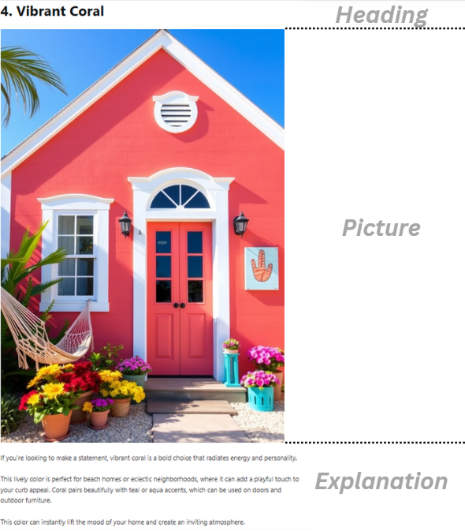

6. Set Featured Image
- Choose a high-quality featured image (recommended size: 1200x628px for most WP themes).

7. Proofread & Optimize Readability
- Ensure clear, natural-sounding language (avoid AI-generated fluff).
- Vary sentence beginnings & eliminate unnecessary repetitions.
- Read your text as if you're the reader—if you enjoy it, your readers will too.
- Using AI? Check our strategy with AI tools & human editing.

8. Set URL
- Keep it short & include your KW (e.g., yourwebsite.com/keyword).
- Avoid long or complex URLs—this helps with (Pinterest) SEO & user experience.

9. Choose and Set Category
A well-structured site improves your navigation & SEO.
Example for a food blog:
- Categories: Pizza, Pasta, Antipasti, Desserts, Wine.
Sort your articles into clear categories so readers find your content easily.

10. Publish
- Review all steps.
- Preview your article.
- Hit publish—you’re done!

Our Introduction, Meta Description and FAQ-Section Prompt:
"Please create a FAQ, meta description and introduction for the following keyword: [Your KW]
1. please write a personal, non-formal, short introduction for a blog article about this keyword. No more than 3-5 sentences. Be creative and friendly, please.
2. please write an engaging meta description (with about 150 characters) including this keyword.
3. create 3 FAQ-appropriate questions that match the keyword and answer them in 2-3 sentences to show Google that I know the niche and to cover other secondary keywords [you can add your secondary keywords or question here if you want]."

